# CS 255 System Design Document Template

Amanda de los Santos

### UML Use Case Diagram

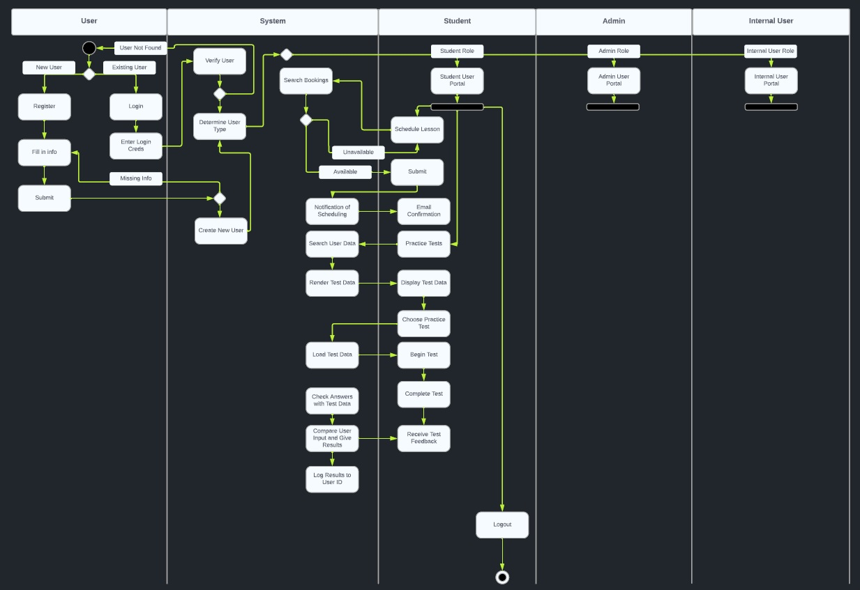

### UML Activity Diagrams

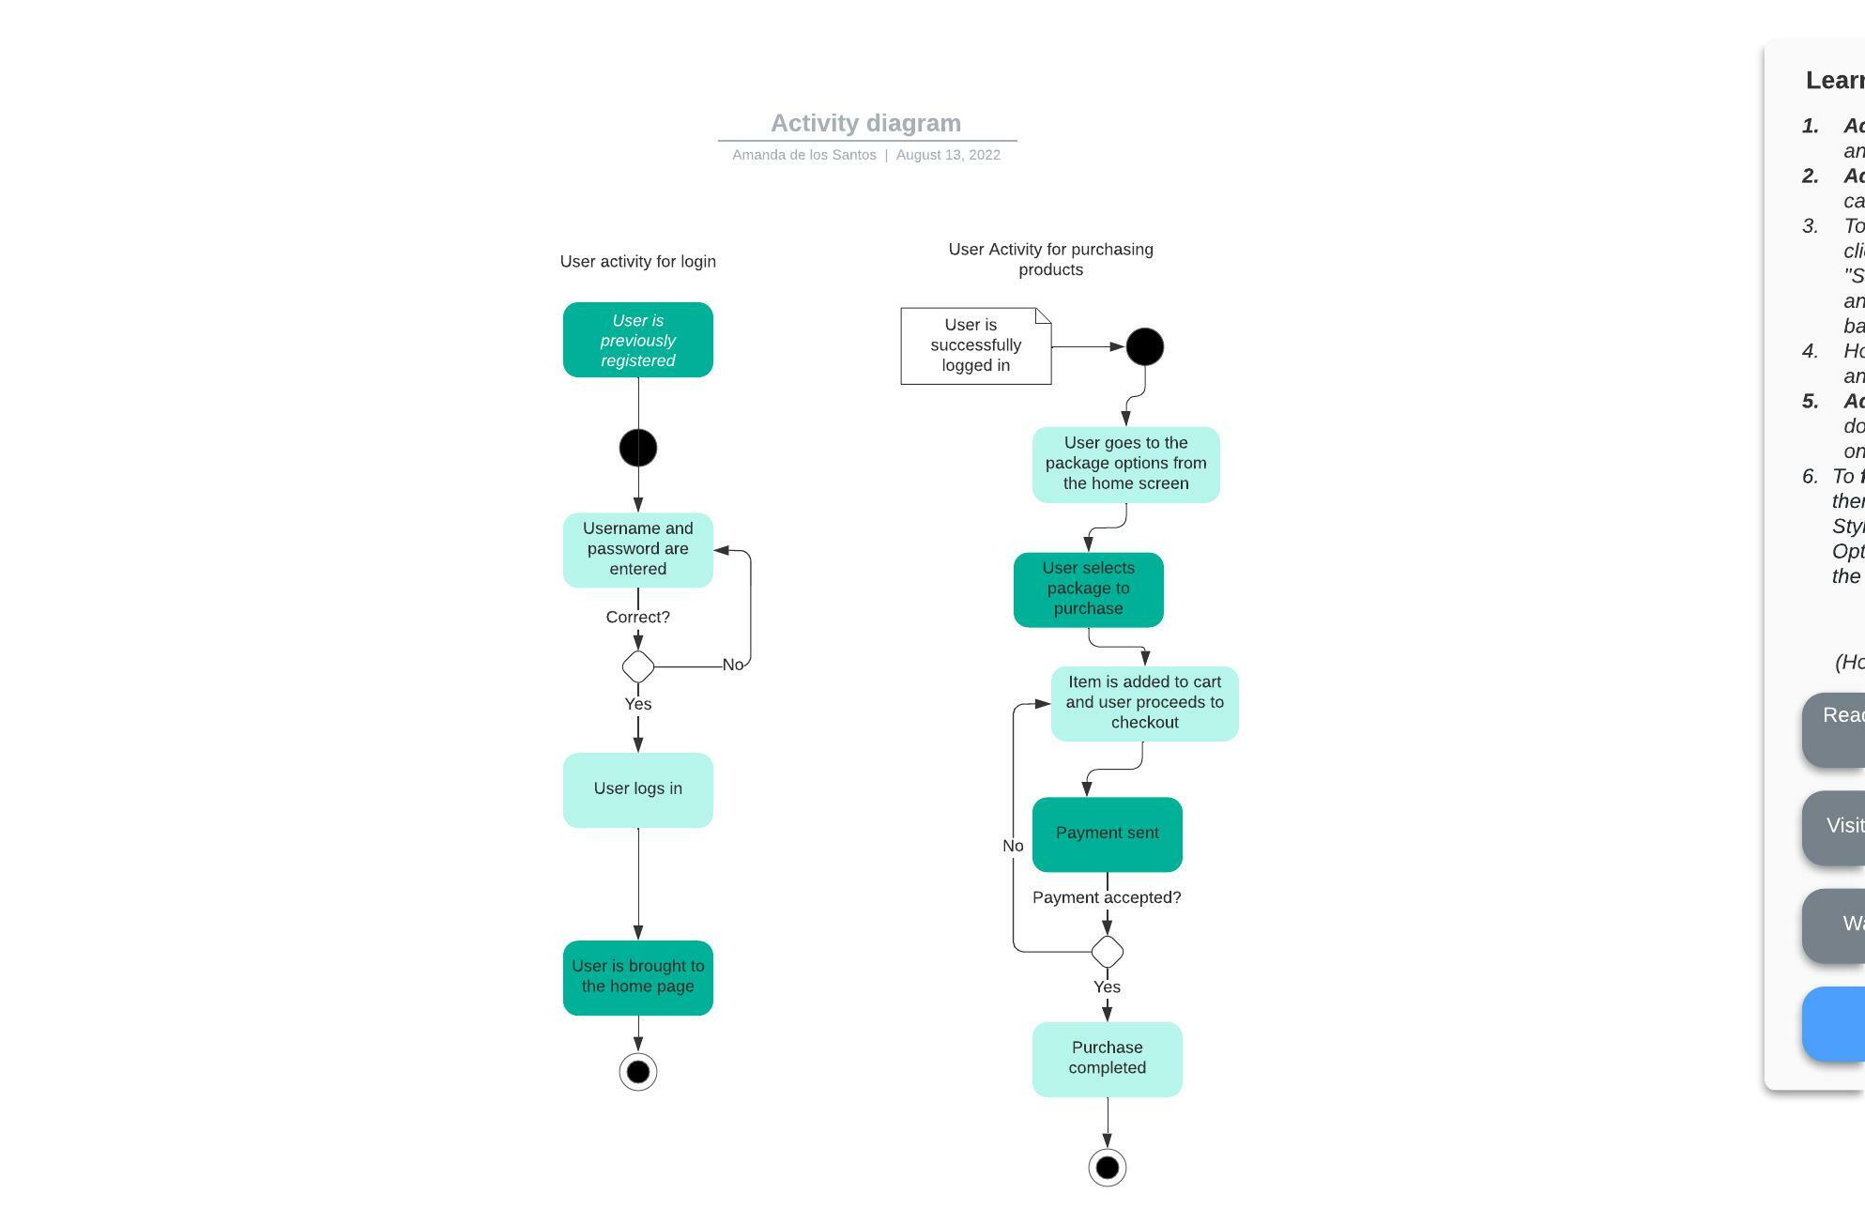

### UML Sequence Diagram

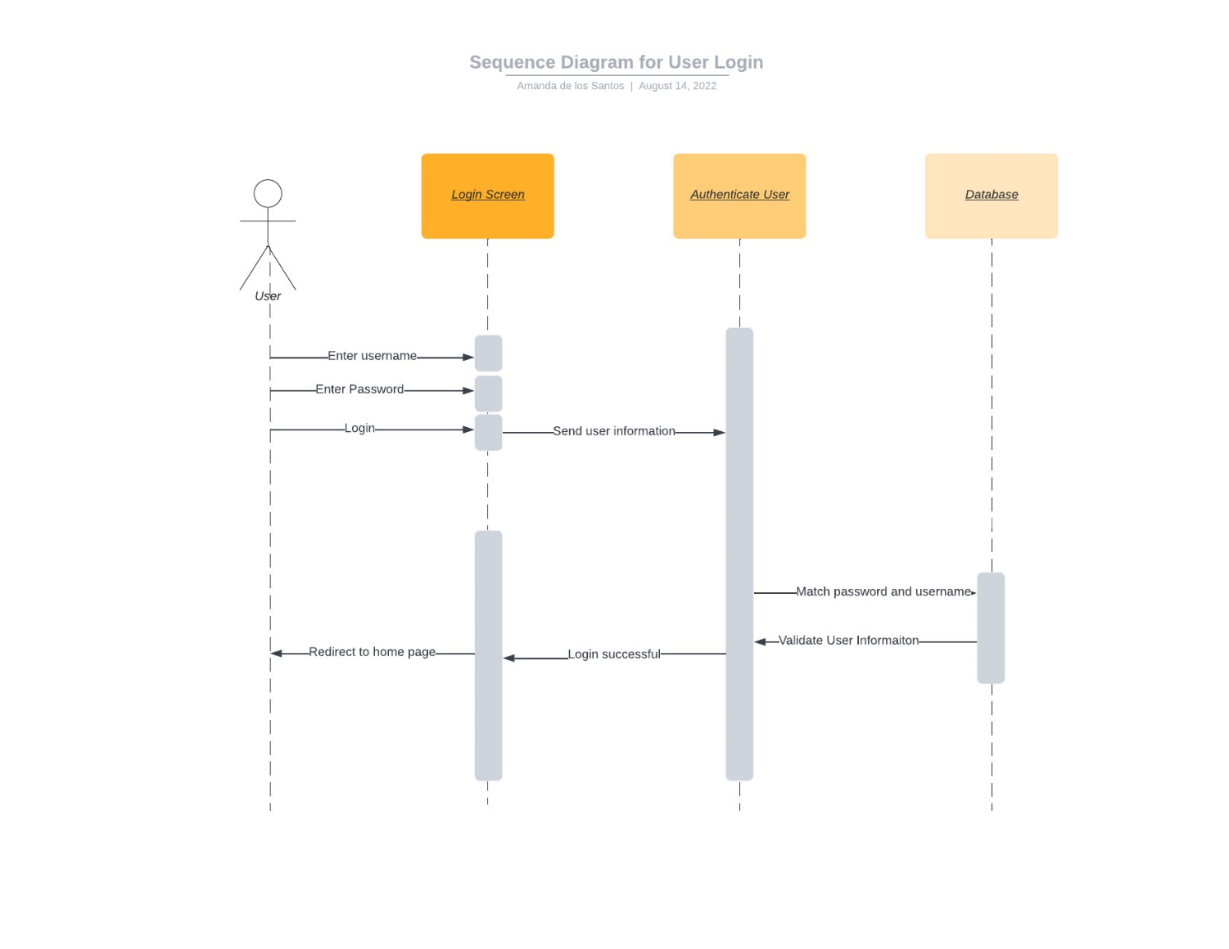

### UML Class Diagram

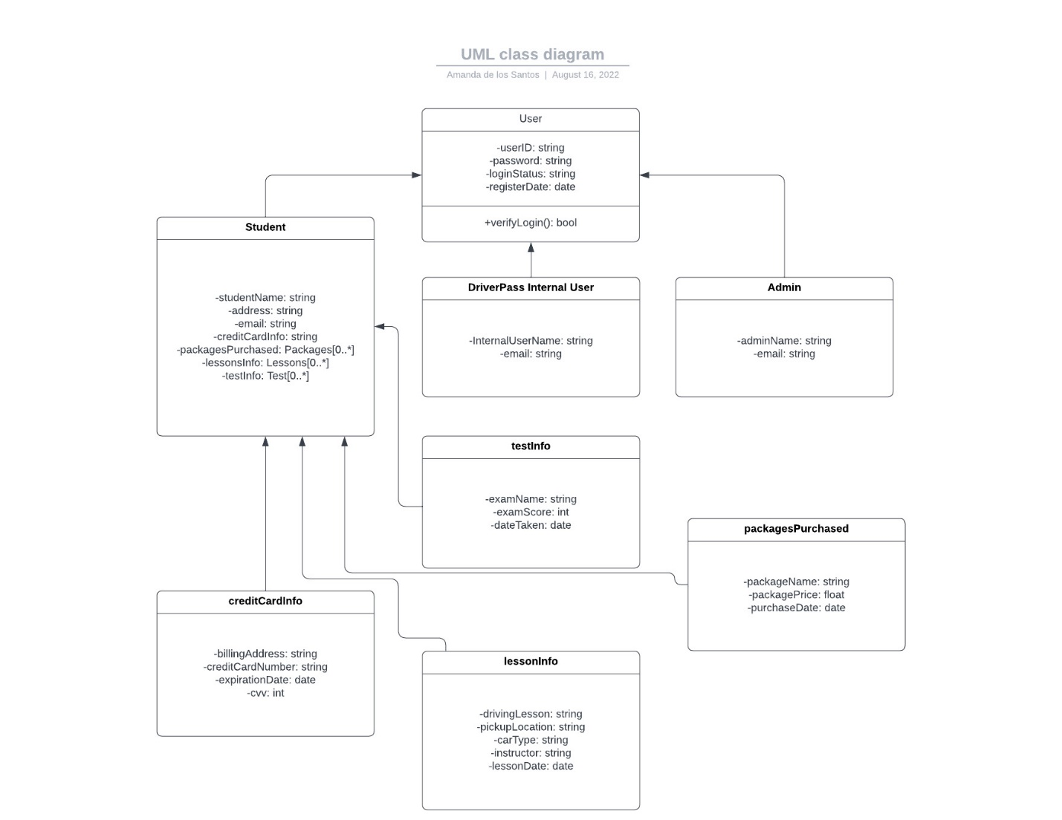

## Technical Requirements

The system will need to be developed to work via the web, as well as the cloud and a mobile version. All information should be available to download to use offline. The system should be usable from all browsers and be usable on both Windows and Mac systems. Use of a containerized system such as Kubernetes will help with the organization of the database. The database should encompass both a cloud and physical data storage to keep all the user information contained in. There needs to be encryption to allow for safer sharing and transferring of user and system information. The cloud platform will allow for updates to easily be completed and rolled out. This will also allow for easier access to any scheduling system and the tracking of the user’s information. All training progress and other pertinent information will be able to be stored and shared via the encrypted network. The security within the system should also only allow access to certain parts of the system for specific users.